**Lab#13 PHP with MySQL connectivity (Forms, Advance PHP and database handling) [Continuing Semester Project] Implement following web pages using PHP:**

**a. Login Page (User and Admin)**

**b. Add a category for the products.**

**Final Outcome:**

1. **Login Page (User)**

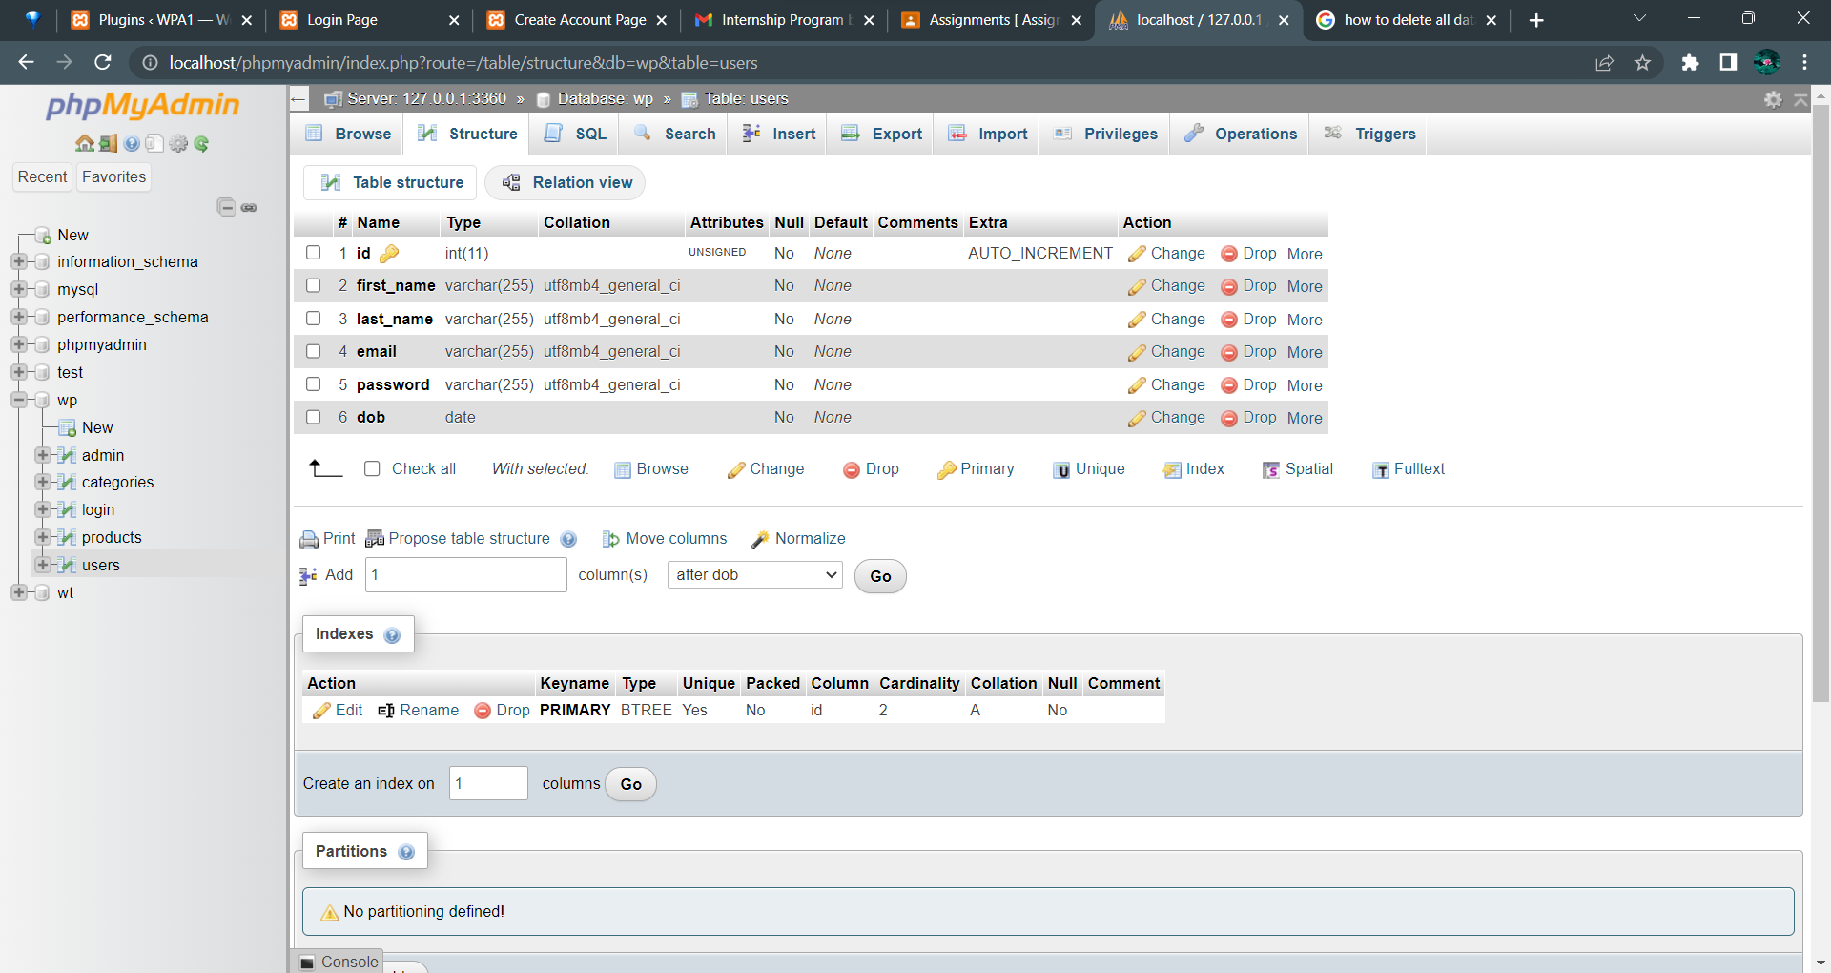

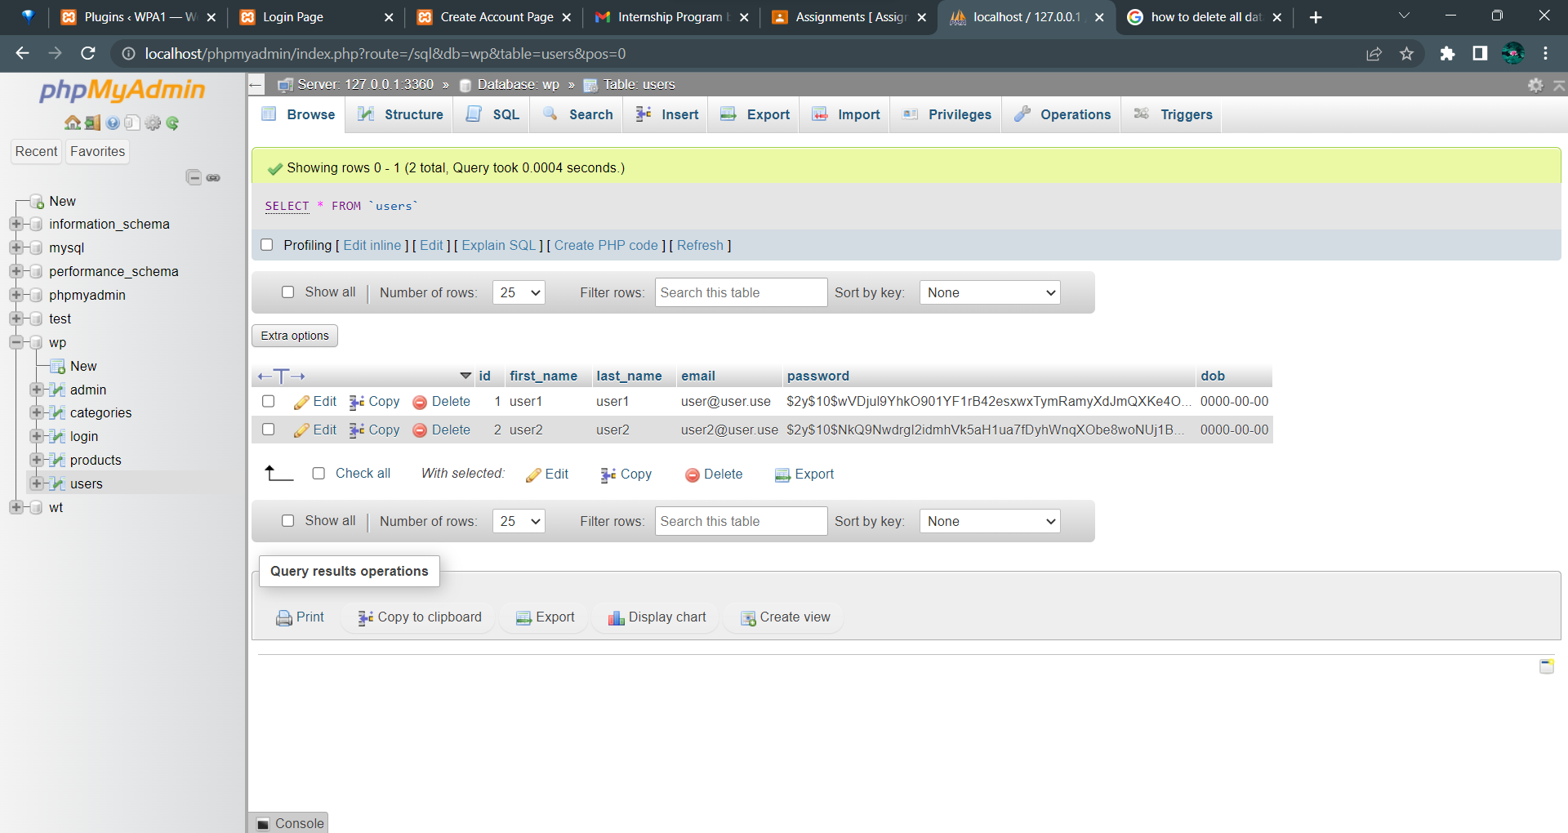

**Login Page (Admin)**

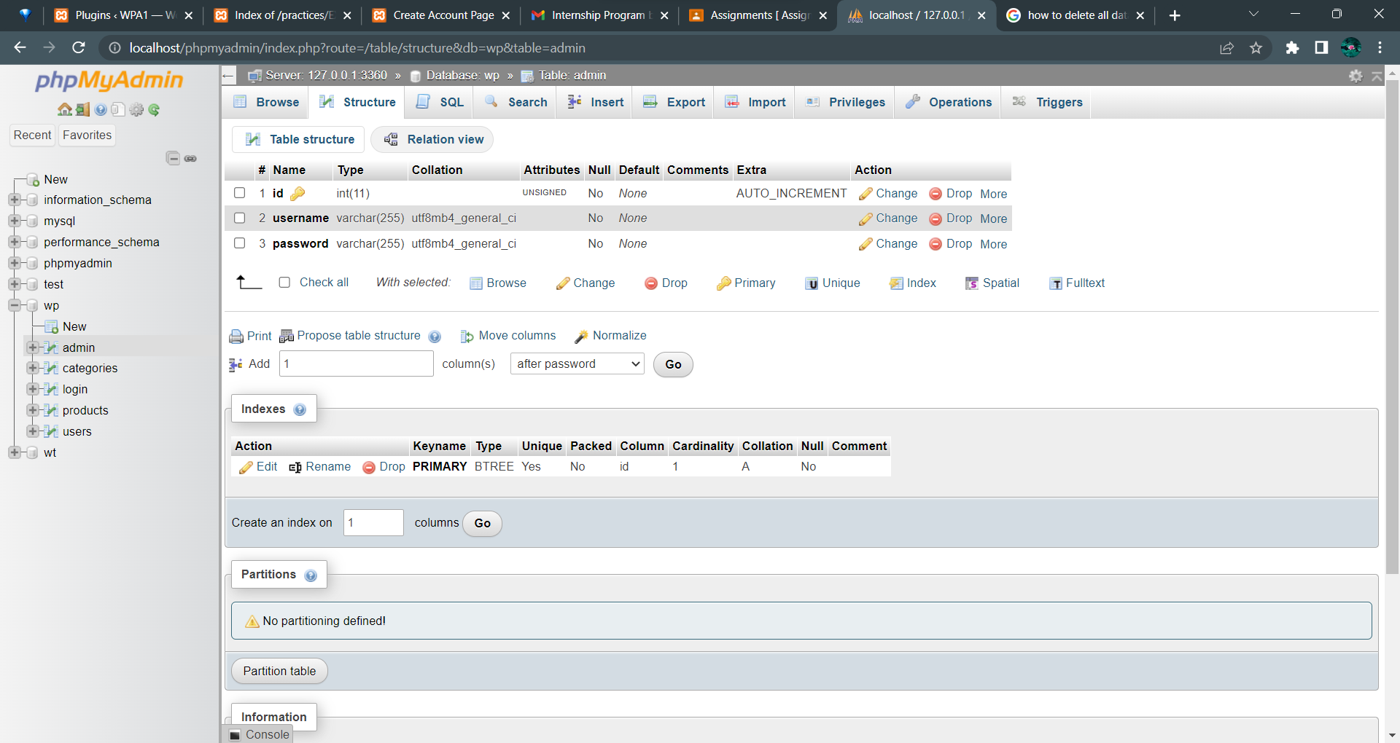

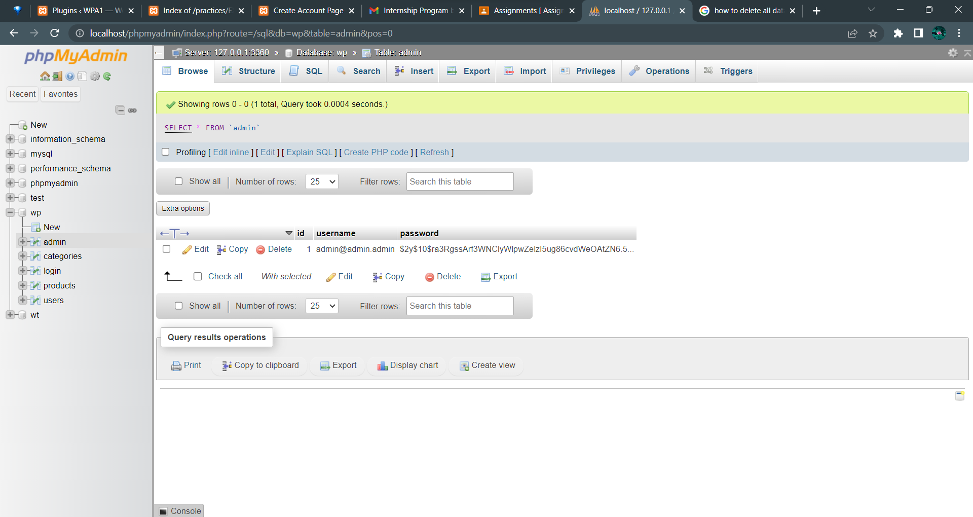

**Code Snippet:**

**/* PHP Snippet */**

**User login Page:**

<?php

$servername = "localhost";

$username = "root";

$passwordD = "";

$db_name = "wp";

$conn = new mysqli($servername, $username, $passwordD, $db_name, 3360);

if ($conn->connect_error) {

die("Connection failed" . $conn->connect_error);

}

echo " ";

if (isset($_POST['submit'])) {

$username = $_POST['email'];

$password = $_POST['password'];

$sql = "SELECT * FROM users WHERE email = '$username'";

$result = mysqli_query($conn, $sql);

$row = mysqli_fetch_array($result, MYSQLI_ASSOC);

$count = mysqli_num_rows($result);

if ($count == 1 && password_verify($password, $row['password'])) {

header("Location: welcom.php");

} else {

echo '<script>

window.location.href = "indexl.php";

alert("Login failed. Invalid username or password!!")

</script>';

}

}

**Admin login Page:**

<?php

$servername = "localhost";

$username = "root";

$passwordD = "";

$db_name = "wp";

$conn = new mysqli($servername, $username, $passwordD, $db_name, 3360);

if ($conn->connect_error) {

die("Connection failed" . $conn->connect_error);

}

if (isset($_POST['submit'])) {

$username = $_POST['email'];

$password = $_POST['password'];

$sql = "SELECT * FROM admin WHERE username = '$username'";

$result = mysqli_query($conn, $sql);

$row = mysqli_fetch_array($result, MYSQLI_ASSOC);

$count = mysqli_num_rows($result);

if ($count == 1) {

// Verify the password

$hashedPassword = $row['password'];

if (password_verify($password, $hashedPassword)) {

header("Location: welcom.php");

exit();

} else {

echo '<script>

window.location.href = "index_al.php";

alert("Login failed. Invalid username or password!!");

</script>'; }

} else {

echo '<script>

window.location.href = "index_al.php";

alert("Login failed. Invalid username or password!!");

</script>';

}

}

**b. Add a category for the products.**

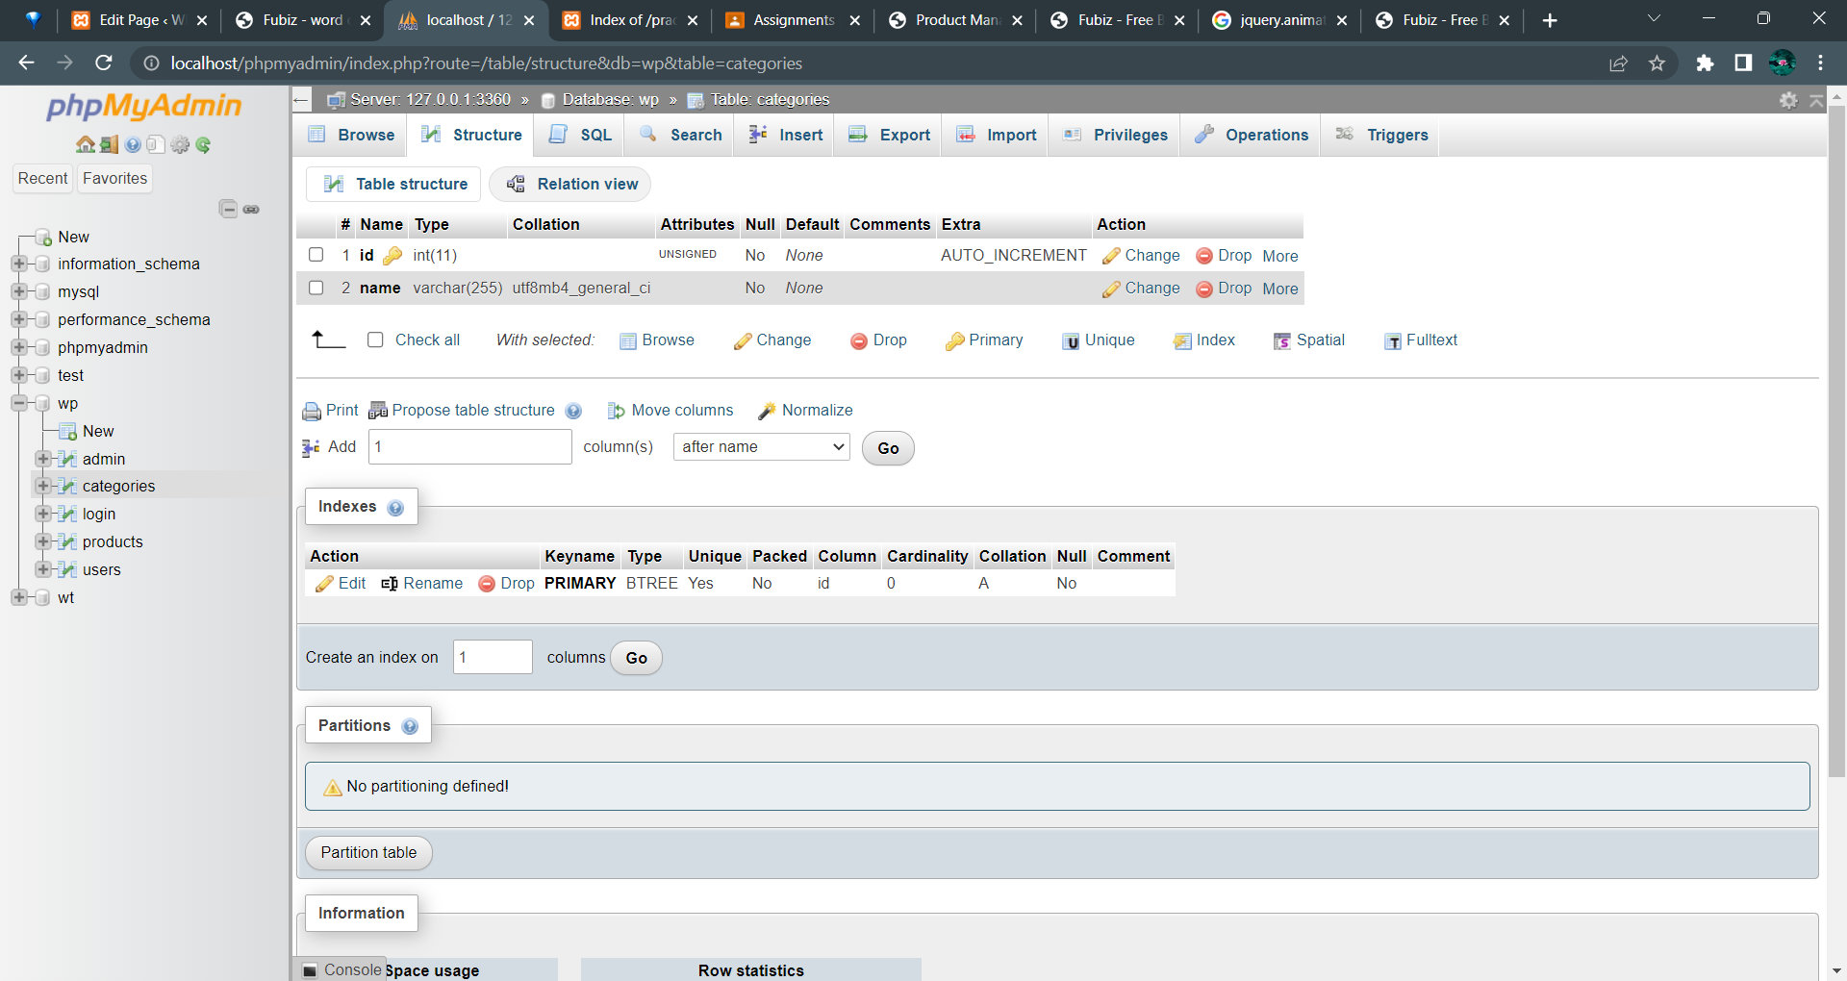

**Category selection:**

<?php

// Database connection details

$servername = "localhost";

$username = "root";

$password = "";

$dbname = "wp";

// Create a connection to the database

$conn = new mysqli($servername, $username, $password, $dbname, 3360);

// Check the connection

if ($conn->connect_error) {

die("Connection failed: " . $conn->connect_error);

}

// Check if a category is selected

if (isset($_POST[category])) {

$selected_category = $_POST[category];

// Fetch laptop data based on the selected category with a limit of three

$sql = "SELECT name, category, description, price, laptop_image FROM laptops WHERE category = '$selected_category' LIMIT 3";

$result = $conn->query($sql);

if ($result && $result->num_rows > 0) {

while ($row = $result->fetch_assoc()) {

$name = $row['name'];

$category = $row['category'];

$description = $row['description'];

$price = $row['price'];

$image_content = $row['laptop_image'];

?>

<div class="flex items-center hover:bg-gray-100 -mx-8 px-6 py-5">

<!-- Rest of the code to display laptop details and image -->

</div>

<?php

}

} else {

echo "No laptops found.";

}

} else {

echo "Please select a category.";

}

// Close the database connection

$conn->close();

?>